**IP Interfaces: Part 2**

Instructions

For the second lab, you will select IP addresses from 10.10.11.0/24 to configure R2, R3, and R4 in Area 1 as shown in the network diagram. Since R2, R3, and R4 are connected by different hubs, they are not in the same broadcast and collision domain, and therefore do not have direct access to each other via Ethernet.

You will configure four different subnets so that each pair of directly connected routers can communicate with each other. But you also must make sure that your subnets do not overlap. Before configuring your VMs, fill in the table and verify that you have assigned appropriate subnets for all three VMs. Each subnet should be large enough to accommodate its routers, but no larger than necessary.

Note that you will assign a /28 on R4 (eth2) to be used later for a subsequent DHCP assignment.

* Each subnet will hold 2 IP addresses. Will require a total of 4 IP addresses for each subnet to include the broadcast and network address. /30 holds 4 IP addresses.
  + R4 using /28 for DHCP
* Subnet IP addresses are distributed in powers of 2. R4 (eth2) has to start from an IP address of 16 to be distributed properly.
  + Subnet boundaries must be a multiple of their size.
  + /28 has to start at 16.
* Broadcast addresses are the highest IP address
* Network addresses are the first IP address

|  |  |  |  |  |
| --- | --- | --- | --- | --- |
| VM (Interface) | IP Address | Network Address | Broadcast Address | Range (usable addresses) |
| R2 (eth1) | 10.10.11.1/30 | 10.10.11.0 | 10.10.11.3 | 10.10.11.1-10.10.11.2 |
| R3 (eth0) | 10.10.11.2/30 |
| R2 (eth2) | 10.10.11.5/30 | 10.10.11.4 | 10.10.11.7 | 10.10.11.5-10.10.11.6 |
| R4(eth1) | 10.10.11.6/30 |
| R3(eth1) | 10.10.11.9/30 | 10.10.11.8 | 10.10.11.11 | 10.10.11.9-10.10.11.10 |
| R4(eth0) | 10.10.11.10/30 |
| R4 (eth2) | 10.10.11.17/28 | 10.10.11.16 | 10.10.11.31 | 10.10.11.16-10.10.11.31 |

Part 1: Configuring Network Interfaces

Use vtysh to do the configurations (See Interface Commands under Zebra in the frrouting manual). Don’t forget to write to memory or your changes will be lost.

You may use Linux’s ifconfig command in order to verify that you have saved your network configuration (see man ifconfig).

**Part 2: Questions**

1. Why must we ensure that our subnets do not overlap? Discuss one example of something that could go wrong. (10 points)

The subnets must not overlap in order to ensure that every IP address in a network is unique and as such, accessible if it exists within the network and has a valid address.

Overlapping subnets will have overlapping IP addresses as well as IP routing tables[1]. If a router needs to send a packet to an IP address of a subnet that overlaps with another, then that packet may be forwarded to an address in the wrong subnet[2].

1. Suppose there is another Router (R5) directly connected to the HUB between R3 and R4. Explain whether or not we would need to reconfigure the IP subnets on R3 and R4 in order to communicate with R5. (10 points)

Yes, the subnet shared by R3 and R4 is of size /30 which contains 4 IP addresses. All 4 of the /30 subnet IP addresses are being occupied by an R3 interface, an R4 interface, the network address, and the broadcast address. They would need their subnets to be changed to a larger one to accommodate an additional IP Address.

1. Run Wireshark on R2 (eth1). Now ping R3(eth1) from R2. Identify what type of packet is used in ping. Why is R2 unable to reach R3 (eth1)? (10 points)

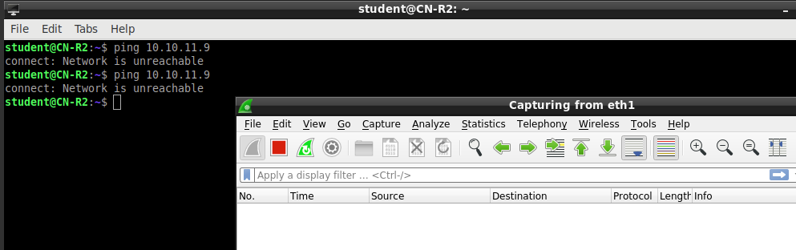

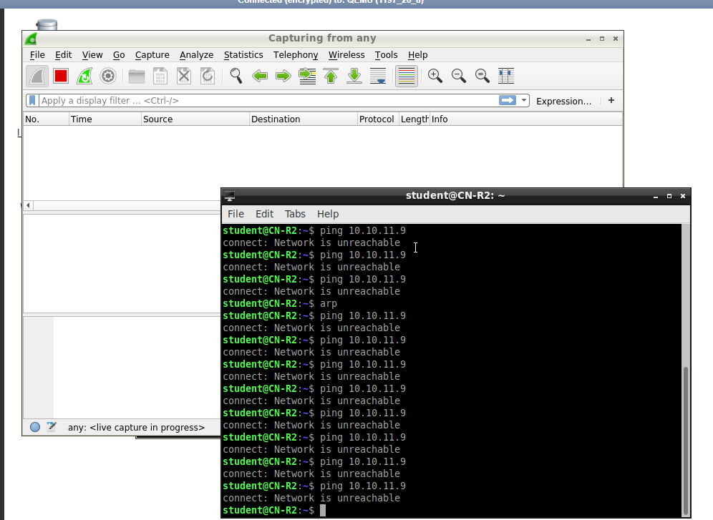

* Wireshark does not detect anything being sent on any interface, including eth1.

R2 does not see R3 within the eth1 interface, so R2 does not send anything through eth1. Wireshark does not see anything being sent through eth1 or any interface because R2 has been set to not broadcast an ARP request on all interfaces under this scenario.

R2 eth1 can’t detect R3 eth1. They are in two different subnets which means a ping from R2 cannot jump from R2’s subnet R3’s subnet. Proxy ARPs and packet forwarding are not being used, and the two subnets have different broadcast addresses and domains, so R2 will not locate R3 through eth1.

Ping uses the ICMP echo request and ICMP echo reply packets. R2 pings by sending an ICMP echo request message to R3. R3 receives the request from R2 then replies by sending an ICMP echo reply message to R2.

R3 pinging R2 shows that the ping protocols being used below. It shows ICMP echo request and ICMP echo reply.

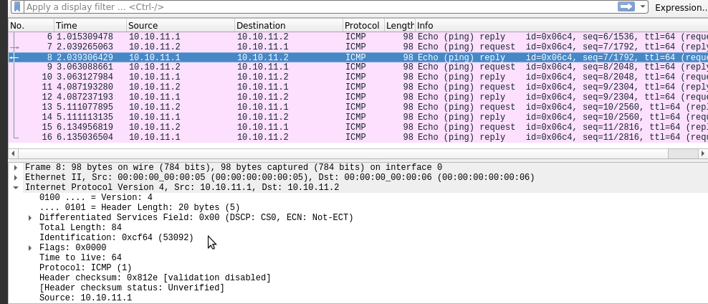

1. Briefly describe how Wireshark results compare when you ping R3 (eth0) from R2 (eth1). (5 points)

Pinging R3 from R2 eth0. R2 is able to locate R3 and its IP address. This is because those two IP addresses are within the same subnet and share the same broadcast address. R3 can broadcast its ARP request to R2 so that both devices can record each other’s ARP information. R2 and R3 are able to locate each other in this subnet.

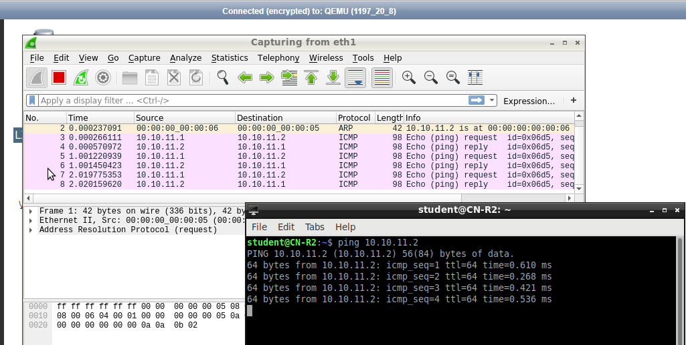

Submissions

[30 pts] Screenshot of the .conf file under /etc/frr/frr.conf from R2, R3, and R4

R2 conf file

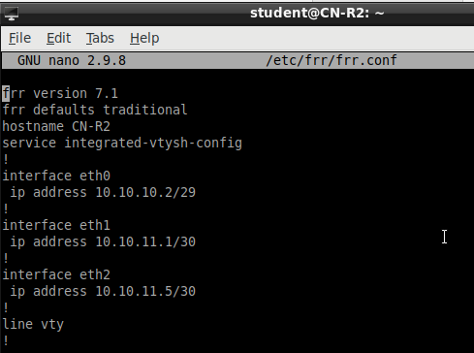

R3 conf file

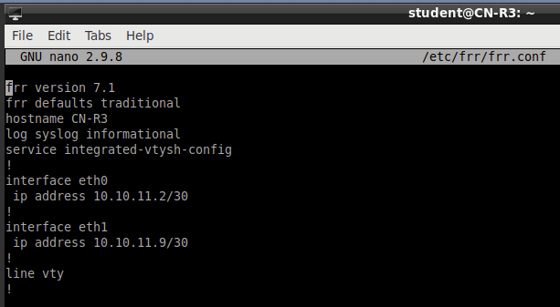

R4 conf table

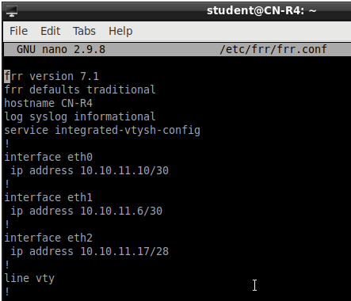

[20 pts] Your IP subnet table

[10 pts] Screenshot showing that pinging works between R2, R3, and R4

R2 pinging R3 (eth0) and R4 (eth1)

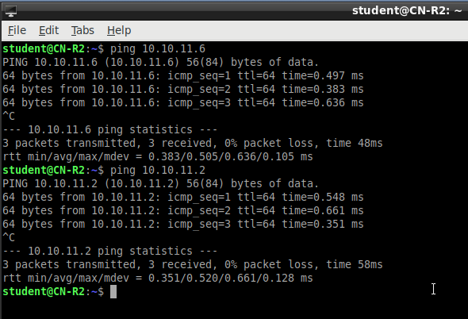

R3 pinging R2 (eth1) and R4 (eth0)

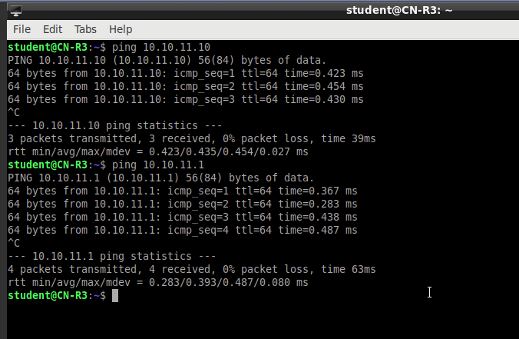

R4 pinging R2 (eth2) and R3 (eth1)

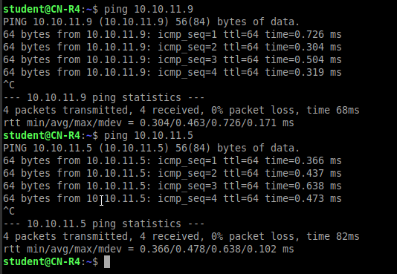

[5 pts] Screenshot of the ARP tables on R2, R3, and R4

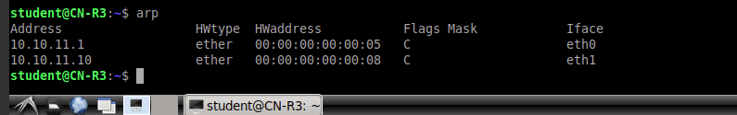 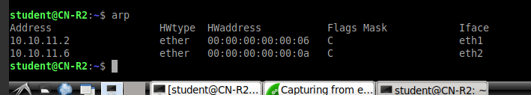

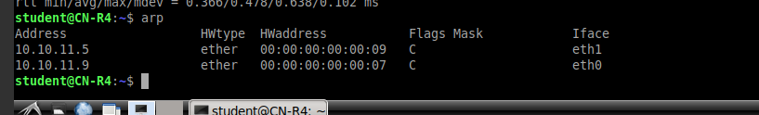

[35 pts] Answers to questions 2a-2d.

1. https://www.ciscopress.com/articles/article.asp?p=2738302&seqNum=2
2. https://blog.certskills.com/vlsmo_01_01/#:~:text=In%20real%20networks%2C%20if%20two,packet%20to%20the%20wrong%20subnet.